|  |  |  |
| --- | --- | --- |
| **Ex.No** |  | **Date** |
|  |  |

**SOURCE CODE:**

**XML CODE:**

<?xml version="1.0" encoding="utf-8"?>  
<LinearLayout xmlns:android="http://schemas.android.com/apk/res/android"  
 android:orientation="vertical"  
 android:layout_width="match_parent"  
 android:layout_height="match_parent"  
 android:padding="16dp">  
  
 <TextView  
 android:id="@+id/textView"  
 android:layout_width="match_parent"  
 android:layout_height="wrap_content"  
 android:layout_margin="30dp"  
 android:gravity="center"  
 android:text="Abishek"  
 android:textSize="25sp"  
 android:textStyle="bold" />  
  
 <Button  
 android:id="@+id/button1"  
 android:layout_width="match_parent"  
 android:layout_height="wrap_content"  
 android:layout_margin="20dp"  
 android:gravity="center"  
 android:text="Change font size"  
 android:textSize="25sp" />  
  
 <Button  
 android:id="@+id/button2"  
 android:layout_width="match_parent"  
 android:layout_height="wrap_content"  
 android:layout_margin="20dp"  
 android:gravity="center"  
 android:text="Change color"  
 android:textSize="25sp" />  
</LinearLayout>

**JAVA CODE:**

package com.example.exno1;  
  
import android.os.Bundle;  
import android.graphics.Color;  
import androidx.appcompat.app.AppCompatActivity;  
import android.view.View;  
import android.widget.Button;  
import android.widget.TextView;  
  
public class MainActivity extends AppCompatActivity {  
  
 int ch = 1;  
 float font = 30;  
  
 @Override  
 protected void onCreate(Bundle savedInstanceState) {  
 super.onCreate(savedInstanceState);  
 setContentView(R.layout.*activity_main*);  
  
 final TextView t = findViewById(R.id.*textView*);  
 Button b1 = findViewById(R.id.*button1*);  
  
 b1.setOnClickListener(new View.OnClickListener() {  
 @Override  
 public void onClick(View v) {  
 t.setTextSize(font);  
 font = font + 5;  
 if (font == 50)  
 font = 30;  
 }  
 });  
  
 Button b2 = findViewById(R.id.*button2*);  
  
 b2.setOnClickListener(new View.OnClickListener() {  
 @Override  
 public void onClick(View v) {  
 switch (ch) {  
 case 1:  
 t.setTextColor(Color.*RED*);  
 break;  
 case 2:  
 t.setTextColor(Color.*GREEN*);  
 break;  
 case 3:  
 t.setTextColor(Color.*BLUE*);  
 break;  
 case 4:  
 t.setTextColor(Color.*CYAN*);  
 break;  
 case 5:  
 t.setTextColor(Color.*YELLOW*);  
 break;  
 case 6:  
 t.setTextColor(Color.*MAGENTA*);  
 break;  
 }  
  
 ch++;  
 if (ch == 7) ch = 1;  
 }  
 });  
 }  
}

**OUTPUT:**

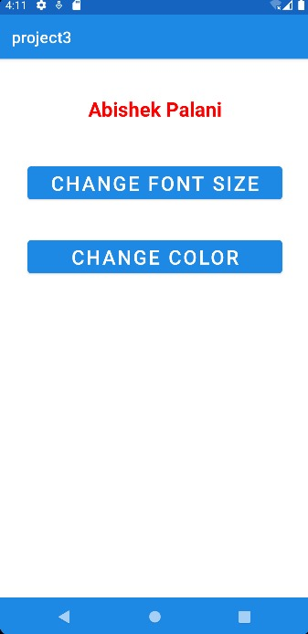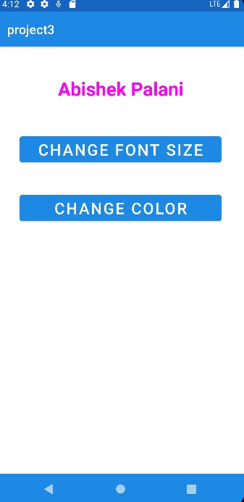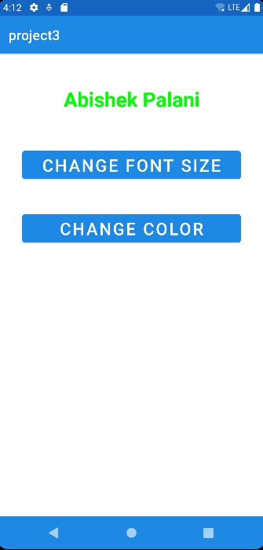

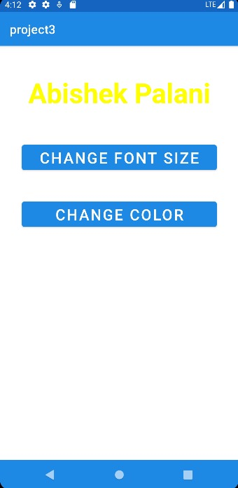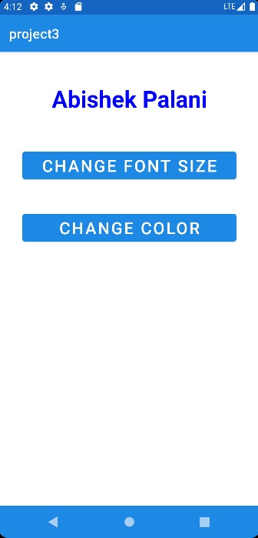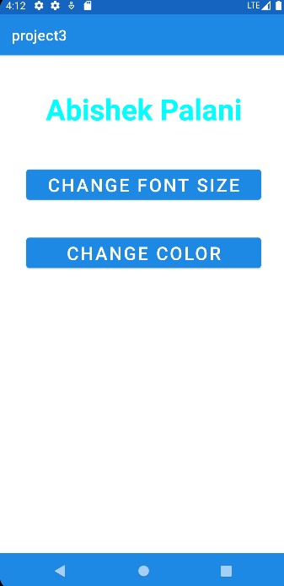

|  |  |  |
| --- | --- | --- |
| **Ex.No** |  | **Date** |
|  |  |

**SOURCE CODE:**

**XML CODE:**

MAIN ACTIVITY 1:

<?xml version="1.0" encoding="utf-8"?>  
<RelativeLayout xmlns:android="http://schemas.android.com/apk/res/android"  
 xmlns:tools="http://schemas.android.com/tools"  
 android:layout_width="match_parent"  
 android:layout_height="match_parent"  
 tools:context=".MainActivity">  
  
 <LinearLayout  
 android:layout_width="match_parent"  
 android:layout_height="100dp">  
  
 <TextView  
 android:id="@+id/textView"  
 android:layout_width="match_parent"  
 android:layout_height="wrap_content"  
 android:layout_margin="30dp"  
 android:text="Details Form"  
 android:textSize="25sp"  
 android:gravity="center" />  
 </LinearLayout>  
  
 <GridLayout  
 android:id="@+id/gridLayout"  
 android:layout_width="match_parent"  
 android:layout_height="match_parent"  
 android:layout_marginTop="100dp"  
 android:layout_marginBottom="200dp"  
 android:columnCount="2"  
 android:rowCount="3">  
  
 <TextView  
 android:id="@+id/textView1"  
 android:layout_width="wrap_content"  
 android:layout_height="wrap_content"  
 android:layout_margin="10dp"  
 android:layout_row="0"  
 android:layout_column="0"  
 android:text="Name"  
 android:textSize="20sp"  
 android:gravity="center" />  
  
 <EditText  
 android:id="@+id/editText"  
 android:layout_width="wrap_content"  
 android:layout_height="wrap_content"  
 android:layout_margin="10dp"  
 android:layout_row="0"  
 android:layout_column="1"  
 android:ems="10" />  
  
 <TextView  
 android:id="@+id/textView2"  
 android:layout_width="wrap_content"  
 android:layout_height="wrap_content"  
 android:layout_margin="10dp"  
 android:layout_row="1"  
 android:layout_column="0"  
 android:text="Reg.No"  
 android:textSize="20sp"  
 android:gravity="center" />  
  
 <EditText  
 android:id="@+id/editText2"  
 android:layout_width="wrap_content"  
 android:layout_height="wrap_content"  
 android:layout_margin="10dp"  
 android:layout_row="1"  
 android:layout_column="1"  
 android:inputType="number"  
 android:ems="10" />  
  
 <TextView  
 android:id="@+id/textView3"  
 android:layout_width="wrap_content"  
 android:layout_height="wrap_content"  
 android:layout_margin="10dp"  
 android:layout_row="2"  
 android:layout_column="0"  
 android:text="Dept"  
 android:textSize="20sp"  
 android:gravity="center" />  
  
 <Spinner  
 android:id="@+id/spinner"  
 android:layout_width="wrap_content"  
 android:layout_height="wrap_content"  
 android:layout_margin="10dp"  
 android:layout_row="2"  
 android:layout_column="1"  
 android:spinnerMode="dropdown" />  
 </GridLayout>  
  
 <Button  
 android:id="@+id/button"  
 android:layout_width="wrap_content"  
 android:layout_height="wrap_content"  
 android:layout_alignParentBottom="true"  
 android:layout_centerInParent="true"  
 android:layout_marginBottom="150dp"  
 android:text="Submit" />  
</RelativeLayout>

MAIN ACTIVITY 2:

<?xml version="1.0" encoding="utf-8"?>  
<LinearLayout xmlns:android="http://schemas.android.com/apk/res/android"  
 xmlns:tools="http://schemas.android.com/tools"  
 android:layout_width="match_parent"  
 android:layout_height="match_parent"  
 tools:context=".SecondActivity"  
 android:orientation="vertical"  
 android:gravity="center">  
  
 <TextView  
 android:id="@+id/textView1"  
 android:layout_width="wrap_content"  
 android:layout_height="wrap_content"  
 android:layout_margin="20dp"  
 android:text="New Text"  
 android:textSize="30sp" />  
  
 <TextView  
 android:id="@+id/textView2"  
 android:layout_width="wrap_content"  
 android:layout_height="wrap_content"  
 android:layout_margin="20dp"  
 android:text="New Text"  
 android:textSize="30sp" />  
  
 <TextView  
 android:id="@+id/textView3"  
 android:layout_width="wrap_content"  
 android:layout_height="wrap_content"  
 android:layout_margin="20dp"  
 android:text="New Text"  
 android:textSize="30sp" />  
</LinearLayout>

**JAVA CODE:**

MainActivity.java:

package com.example.exno2;  
  
import android.content.Intent;  
import androidx.appcompat.app.AppCompatActivity;  
import android.os.Bundle;  
import android.view.View;  
import android.widget.ArrayAdapter;  
import android.widget.Button;  
import android.widget.EditText;  
import android.widget.Spinner;  
  
public class MainActivity extends AppCompatActivity {  
  
 EditText e1, e2;  
 Button bt;  
 Spinner s;  
  
 String[] dept_array = {"CSE", "ECE", "IT", "Mech", "Civil"};  
 String name, reg, dept;  
  
 @Override  
 protected void onCreate(Bundle savedInstanceState) {  
 super.onCreate(savedInstanceState);  
 setContentView(R.layout.*activity_main*);  
  
 e1 = findViewById(R.id.*editText*);  
 e2 = findViewById(R.id.*editText2*);  
 bt = findViewById(R.id.*button*);  
 s = findViewById(R.id.*spinner*);  
  
 ArrayAdapter<String> adapter = new ArrayAdapter<>(MainActivity.this, android.R.layout.*simple_spinner_item*, dept_array);  
 adapter.setDropDownViewResource(android.R.layout.*simple_spinner_dropdown_item*);   
 s.setAdapter(adapter);  
  
 bt.setOnClickListener(new View.OnClickListener() {  
 @Override  
 public void onClick(View v) {  
 name = e1.getText().toString();  
 reg = e2.getText().toString();  
 dept = s.getSelectedItem().toString();  
  
 Intent i = new Intent(MainActivity.this, SecondActivity.class);  
  
 i.putExtra("name_key", name);  
 i.putExtra("reg_key", reg);  
 i.putExtra("dept_key", dept);  
  
 startActivity(i);  
 }  
 });  
 }  
}

**SECONDACTIVITY.JAVA:**

package com.example.exno2;  
  
import android.content.Intent;  
import androidx.appcompat.app.AppCompatActivity;  
import android.os.Bundle;  
import android.widget.TextView;  
  
public class SecondActivity extends AppCompatActivity {  
  
 TextView t1, t2, t3;  
 String name, reg, dept;  
  
 @Override  
 protected void onCreate(Bundle savedInstanceState) {  
 super.onCreate(savedInstanceState);  
 setContentView(R.layout.*activity_second*);  
  
 t1 = findViewById(R.id.*textView1*);  
 t2 = findViewById(R.id.*textView2*);  
 t3 = findViewById(R.id.*textView3*);  
  
 Intent i = getIntent();  
  
 name = i.getStringExtra("name_key");  
 reg = i.getStringExtra("reg_key");  
 dept = i.getStringExtra("dept_key");  
  
 t1.setText(name);  
 t2.setText(reg);  
 t3.setText(dept);  
 }  
}

**OUTPUT:**

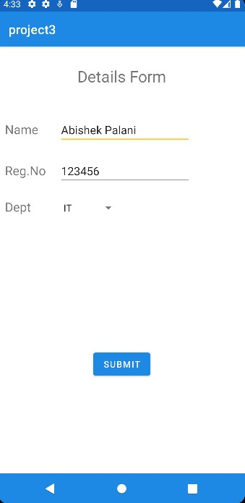 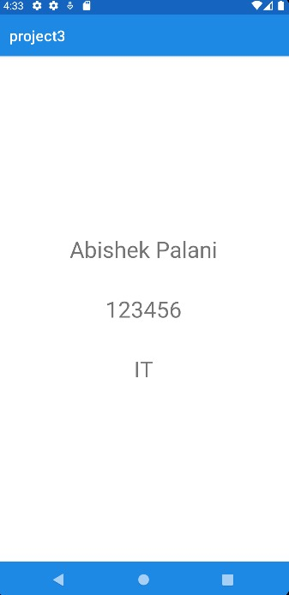

|  |  |  |
| --- | --- | --- |
| **Ex.No** |  | **Date** |
|  |  |

**SOURCE CODE:**

**XML CODE:**

<?xml version="1.0" encoding="utf-8"?>  
<LinearLayout xmlns:android="http://schemas.android.com/apk/res/android"  
 android:orientation="vertical"  
 android:layout_width="match_parent"  
 android:layout_height="match_parent"  
 android:layout_margin="20dp">  
  
 <EditText  
 android:id="@+id/editText1"  
 android:layout_width="match_parent"  
 android:layout_height="wrap_content"  
 android:inputType="numberDecimal"  
 android:textSize="20sp"  
 android:hint="Enter first number"/>  
  
 <EditText  
 android:id="@+id/editText2"  
 android:layout_width="match_parent"  
 android:layout_height="wrap_content"  
 android:inputType="numberDecimal"  
 android:textSize="20sp"  
 android:hint="Enter second number"/>  
  
 <LinearLayout  
 android:layout_width="match_parent"  
 android:layout_height="wrap_content"  
 android:orientation="horizontal">  
  
 <Button  
 android:id="@+id/buttonAdd"  
 android:layout_width="0dp"  
 android:layout_height="wrap_content"  
 android:layout_weight="1"  
 android:text="+"  
 android:textSize="30sp" />  
  
 <Button  
 android:id="@+id/buttonSub"  
 android:layout_width="0dp"  
 android:layout_height="wrap_content"  
 android:layout_weight="1"  
 android:text="-"  
 android:textSize="30sp" />  
  
 <Button  
 android:id="@+id/buttonMul"  
 android:layout_width="0dp"  
 android:layout_height="wrap_content"  
 android:layout_weight="1"  
 android:text="*"  
 android:textSize="30sp" />  
  
 <Button  
 android:id="@+id/buttonDiv"  
 android:layout_width="0dp"  
 android:layout_height="wrap_content"  
 android:layout_weight="1"  
 android:text="/"  
 android:textSize="30sp" />  
 </LinearLayout>  
  
 <TextView  
 android:id="@+id/textViewResult"  
 android:layout_width="wrap_content"  
 android:layout_height="wrap_content"  
 android:text="Answer is"  
 android:textSize="30sp"  
 android:layout_gravity="center"  
 android:layout_marginTop="50dp"/>  
</LinearLayout>

**JAVA CODE:**

package com.example.exno3;  
  
import android.os.Bundle;  
import android.text.TextUtils;  
import android.view.View;  
import android.widget.Button;  
import android.widget.EditText;  
import android.widget.TextView;  
import androidx.appcompat.app.AppCompatActivity;  
  
public class MainActivity extends AppCompatActivity {  
  
 EditText editText1, editText2;  
 Button buttonAdd, buttonSub, buttonMul, buttonDiv;  
 TextView textViewResult;  
  
 @Override  
 protected void onCreate(Bundle savedInstanceState) {  
 super.onCreate(savedInstanceState);  
 setContentView(R.layout.*activity_main*);  
  
 editText1 = findViewById(R.id.*editText1*);  
 editText2 = findViewById(R.id.*editText2*);  
 buttonAdd = findViewById(R.id.*buttonAdd*);  
 buttonSub = findViewById(R.id.*buttonSub*);  
 buttonMul = findViewById(R.id.*buttonMul*);  
 buttonDiv = findViewById(R.id.*buttonDiv*);  
 textViewResult = findViewById(R.id.*textViewResult*);  
  
 buttonAdd.setOnClickListener(new View.OnClickListener() {  
 @Override  
 public void onClick(View v) {  
 calculate("+");  
 }  
 });  
  
 buttonSub.setOnClickListener(new View.OnClickListener() {  
 @Override  
 public void onClick(View v) {  
 calculate("-");  
 }  
 });  
  
 buttonMul.setOnClickListener(new View.OnClickListener() {  
 @Override  
 public void onClick(View v) {  
 calculate("*");  
 }  
 });  
  
 buttonDiv.setOnClickListener(new View.OnClickListener() {  
 @Override  
 public void onClick(View v) {  
 calculate("/");  
 }  
 });  
 }  
  
 private void calculate(String operator) {  
 String input1 = editText1.getText().toString();  
 String input2 = editText2.getText().toString();  
  
 if (TextUtils.*isEmpty*(input1) || TextUtils.*isEmpty*(input2)) {  
 textViewResult.setText("Please enter both numbers");  
 return;  
 }  
  
 float num1 = Float.*parseFloat*(input1);  
 float num2 = Float.*parseFloat*(input2);  
 float result = 0;  
  
 switch (operator) {  
 case "+":  
 result = num1 + num2;  
 break;  
 case "-":  
 result = num1 - num2;  
 break;  
 case "*":  
 result = num1 * num2;  
 break;  
 case "/":  
 if (num2 != 0) {  
 result = num1 / num2;  
 } else {  
 textViewResult.setText("Cannot divide by zero");  
 return;  
 }  
 break;  
 }  
  
 textViewResult.setText("Result: " + result);  
 }  
}

**OUTPUT:**

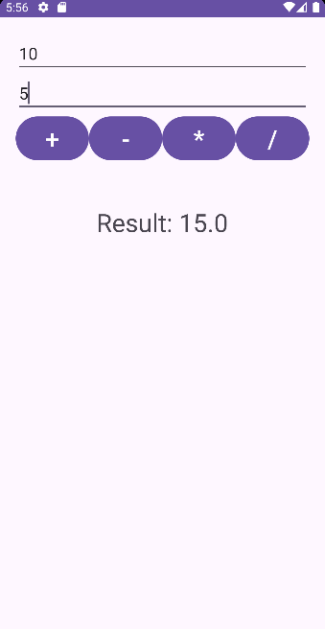 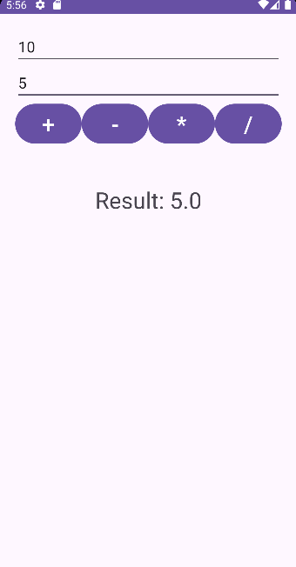

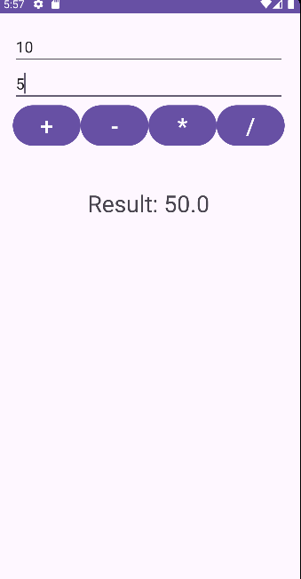 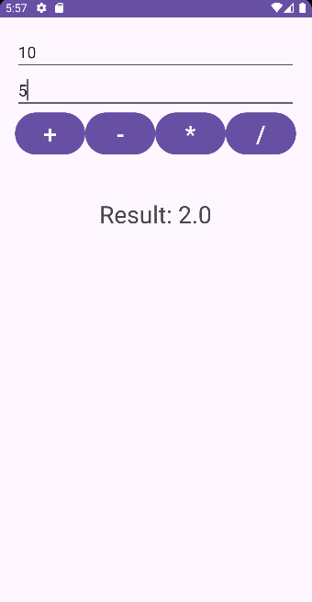

|  |  |  |
| --- | --- | --- |
| **Ex.No** |  | **Date** |
|  |  |

**SOURCE CODE:**

**XML CODE:**

<?xml version="1.0" encoding="utf-8"?>  
<RelativeLayout  
 xmlns:android="http://schemas.android.com/apk/res/android"  
 android:layout_width="match_parent"  
 android:layout_height="match_parent">  
  
 <ImageView  
 android:id="@+id/imageView"  
 android:layout_width="match_parent"  
 android:layout_height="match_parent"  
 android:scaleType="centerCrop" />  
</RelativeLayout>

**JAVA CODE:**

package com.example.exno4;  
  
import android.app.Activity;  
import android.graphics.Bitmap;  
import android.graphics.Canvas;  
import android.graphics.Color;  
import android.graphics.Paint;  
import android.graphics.drawable.BitmapDrawable;  
import android.os.Bundle;  
import android.widget.ImageView;  
  
public class MainActivity extends Activity {  
 @Override  
 public void onCreate(Bundle savedInstanceState) {  
 super.onCreate(savedInstanceState);  
 setContentView(R.layout.*activity_main*);  
  
 Bitmap bg = Bitmap.*createBitmap*(720, 1280, Bitmap.Config.*ARGB_8888*);  
  
 ImageView imageView = (ImageView) findViewById(R.id.*imageView*);  
 imageView.setBackground(new BitmapDrawable(getResources(), bg));  
  
 Canvas canvas = new Canvas(bg);  
  
 Paint paint = new Paint();  
 paint.setColor(Color.*BLUE*);  
 paint.setTextSize(50);  
  
 canvas.drawText("Rectangle", 420, 150, paint);  
 canvas.drawRect(400, 200, 650, 700, paint);  
  
 canvas.drawText("Circle", 120, 150, paint);  
 canvas.drawCircle(200, 350, 150, paint);  
  
 canvas.drawText("Square", 120, 800, paint);  
 canvas.drawRect(50, 850, 350, 1150, paint);  
  
 canvas.drawText("Line", 480, 800, paint);  
 canvas.drawLine(520, 850, 520, 1150, paint);  
 }  
}

**OUTPUT:**

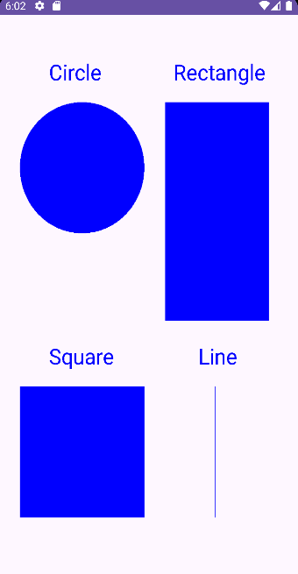

|  |  |  |
| --- | --- | --- |
| **Ex.No** |  | **Date** |
|  |  |

**SOURCE CODE:**

**XML CODE:**

<?xml version="1.0" encoding="utf-8"?>  
<RelativeLayout  
 xmlns:android="http://schemas.android.com/apk/res/android"  
 android:layout_width="match_parent"  
 android:layout_height="match_parent"  
 android:padding="20dp">  
  
 <TextView  
 android:id="@+id/title"  
 android:layout_width="wrap_content"  
 android:layout_height="wrap_content"  
 android:text="Student Details"  
 android:textSize="30sp"  
 android:layout_centerHorizontal="true"  
 android:layout_marginBottom="30dp" />  
  
 <TextView  
 android:id="@+id/rollno_label"  
 android:layout_width="wrap_content"  
 android:layout_height="wrap_content"  
 android:text="Enter Rollno:"  
 android:textSize="20sp"  
 android:layout_below="@id/title"  
 android:layout_marginTop="20dp" />  
  
 <EditText  
 android:id="@+id/Rollno"  
 android:layout_width="150dp"  
 android:layout_height="wrap_content"  
 android:inputType="number"  
 android:textSize="20sp"  
 android:layout_alignParentRight="true"  
 android:layout_toEndOf="@id/rollno_label"  
 android:layout_marginLeft="20dp"  
 android:layout_below="@id/title"  
 android:layout_marginTop="20dp" />  
  
 <TextView  
 android:id="@+id/name_label"  
 android:layout_width="wrap_content"  
 android:layout_height="wrap_content"  
 android:text="Enter Name:"  
 android:textSize="20sp"  
 android:layout_below="@id/rollno_label"  
 android:layout_marginTop="20dp" />  
  
 <EditText  
 android:id="@+id/Name"  
 android:layout_width="150dp"  
 android:layout_height="wrap_content"  
 android:inputType="text"  
 android:textSize="20sp"  
 android:layout_alignParentRight="true"  
 android:layout_toEndOf="@id/name_label"  
 android:layout_marginLeft="20dp"  
 android:layout_below="@id/rollno_label"  
 android:layout_marginTop="20dp" />  
  
 <TextView  
 android:id="@+id/marks_label"  
 android:layout_width="wrap_content"  
 android:layout_height="wrap_content"  
 android:text="Enter Marks:"  
 android:textSize="20sp"  
 android:layout_below="@id/name_label"  
 android:layout_marginTop="20dp" />  
  
 <EditText  
 android:id="@+id/Marks"  
 android:layout_width="150dp"  
 android:layout_height="wrap_content"  
 android:inputType="number"  
 android:textSize="20sp"  
 android:layout_alignParentRight="true"  
 android:layout_toEndOf="@id/marks_label"  
 android:layout_marginLeft="20dp"  
 android:layout_below="@id/name_label"  
 android:layout_marginTop="20dp" />  
  
 <Button  
 android:id="@+id/Insert"  
 android:layout_width="150dp"  
 android:layout_height="wrap_content"  
 android:text="Insert"  
 android:textSize="30sp"  
 android:layout_below="@id/Marks"  
 android:layout_marginTop="30dp"  
 android:layout_alignParentStart="true" />  
  
 <Button  
 android:id="@+id/Delete"  
 android:layout_width="150dp"  
 android:layout_height="wrap_content"  
 android:layout_below="@id/Marks"  
 android:layout_marginStart="45dp"  
 android:layout_marginTop="30dp"  
 android:layout_toEndOf="@id/Insert"  
 android:text="Delete"  
 android:textSize="30sp" />  
  
 <Button  
 android:id="@+id/Update"  
 android:layout_width="150dp"  
 android:layout_height="wrap_content"  
 android:text="Update"  
 android:textSize="30sp"  
 android:layout_below="@id/Delete"  
 android:layout_marginTop="20dp"  
 android:layout_alignParentStart="true" />  
  
 <Button  
 android:id="@+id/View"  
 android:layout_width="150dp"  
 android:layout_height="wrap_content"  
 android:layout_below="@id/Delete"  
 android:layout_marginStart="51dp"  
 android:layout_marginTop="23dp"  
 android:layout_toEndOf="@id/Update"  
 android:text="View"  
 android:textSize="30sp" />  
  
 <Button  
 android:id="@+id/ViewAll"  
 android:layout_width="200dp"  
 android:layout_height="wrap_content"  
 android:text="View All"  
 android:textSize="30sp"  
 android:layout_below="@id/View"  
 android:layout_marginTop="30dp"  
 android:layout_centerHorizontal="true" />  
  
</RelativeLayout>

**JAVA CODE:**

package com.example.exno5;  
  
import android.app.Activity;  
import android.app.AlertDialog.Builder;  
import android.content.Context;  
import android.database.Cursor;  
import android.database.sqlite.SQLiteDatabase;  
import android.os.Bundle;  
import android.view.View;  
import android.widget.Button;  
import android.widget.EditText;  
  
public class MainActivity extends Activity implements View.OnClickListener {  
  
 EditText Rollno, Name, Marks;  
 Button Insert, Delete, Update, View, ViewAll;  
 SQLiteDatabase db;  
  
 @Override  
 protected void onCreate(Bundle savedInstanceState) {  
 super.onCreate(savedInstanceState);  
 setContentView(R.layout.*activity_main*);  
  
 Rollno = findViewById(R.id.*Rollno*);  
 Name = findViewById(R.id.*Name*);  
 Marks = findViewById(R.id.*Marks*);  
 Insert = findViewById(R.id.*Insert*);  
 Delete = findViewById(R.id.*Delete*);  
 Update = findViewById(R.id.*Update*);  
 View = findViewById(R.id.*View*);  
 ViewAll = findViewById(R.id.*ViewAll*);  
  
 Insert.setOnClickListener(this);  
 Delete.setOnClickListener(this);  
 Update.setOnClickListener(this);  
 View.setOnClickListener(this);  
 ViewAll.setOnClickListener(this);  
  
 db = openOrCreateDatabase("StudentDB", Context.*MODE_PRIVATE*, null);  
 db.execSQL("CREATE TABLE IF NOT EXISTS student(rollno VARCHAR, name VARCHAR, marks VARCHAR);");  
 }  
  
 @Override  
 public void onClick(View view) {  
 if (view == Insert) {  
 if (Rollno.getText().toString().trim().isEmpty() || Name.getText().toString().trim().isEmpty() || Marks.getText().toString().trim().isEmpty()) {  
 showMessage("Error", "Please enter all values");  
 return;  
 }  
 db.execSQL("INSERT INTO student VALUES('" + Rollno.getText() + "','" + Name.getText() + "','" + Marks.getText() + "');");  
 showMessage("Success", "Record added");  
 clearText();  
 }  
  
 if (view == Delete) {  
 if (Rollno.getText().toString().trim().isEmpty()) {  
 showMessage("Error", "Please enter Rollno");  
 return;  
 }  
 Cursor c = db.rawQuery("SELECT * FROM student WHERE rollno='" + Rollno.getText() + "'", null);  
 if (c.moveToFirst()) {  
 db.execSQL("DELETE FROM student WHERE rollno='" + Rollno.getText() + "'");  
 showMessage("Success", "Record Deleted");  
 } else {  
 showMessage("Error", "Invalid Rollno");  
 }  
 clearText();  
 }  
  
 if (view == Update) {  
 if (Rollno.getText().toString().trim().isEmpty()) {  
 showMessage("Error", "Please enter Rollno");  
 return;  
 }  
 Cursor c = db.rawQuery("SELECT * FROM student WHERE rollno='" + Rollno.getText() + "'", null);  
 if (c.moveToFirst()) {  
 db.execSQL("UPDATE student SET name='" + Name.getText() + "', marks='" + Marks.getText() + "' WHERE rollno='" + Rollno.getText() + "'");  
 showMessage("Success", "Record Modified");  
 } else {  
 showMessage("Error", "Invalid Rollno");  
 }  
 clearText();  
 }  
  
 if (view == View) {  
 if (Rollno.getText().toString().trim().isEmpty()) {  
 showMessage("Error", "Please enter Rollno");  
 return;  
 }  
 Cursor c = db.rawQuery("SELECT * FROM student WHERE rollno='" + Rollno.getText() + "'", null);  
 if (c.moveToFirst()) {  
 Name.setText(c.getString(1));  
 Marks.setText(c.getString(2));  
 } else {  
 showMessage("Error", "Invalid Rollno");  
 clearText();  
 }  
 }  
  
 if (view == ViewAll) {  
 Cursor c = db.rawQuery("SELECT * FROM student", null);  
 if (c.getCount() == 0) {  
 showMessage("Error", "No records found");  
 return;  
 }  
 StringBuilder buffer = new StringBuilder();  
 while (c.moveToNext()) {  
 buffer.append("Rollno: ").append(c.getString(0)).append("\n");  
 buffer.append("Name: ").append(c.getString(1)).append("\n");  
 buffer.append("Marks: ").append(c.getString(2)).append("\n\n");  
 }  
 showMessage("Student Details", buffer.toString());  
 }  
 }  
  
 public void showMessage(String title, String message) {  
 Builder builder = new Builder(this);  
 builder.setCancelable(true);  
 builder.setTitle(title);  
 builder.setMessage(message);  
 builder.show();  
 }  
  
 public void clearText() {  
 Rollno.setText("");  
 Name.setText("");  
 Marks.setText("");  
 Rollno.requestFocus();  
 }  
}

**OUTPUT:**

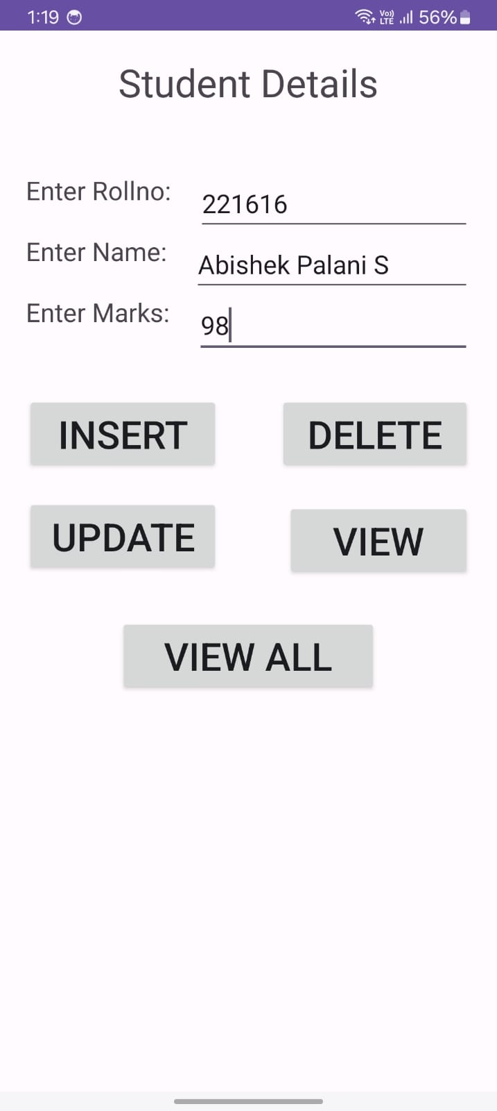 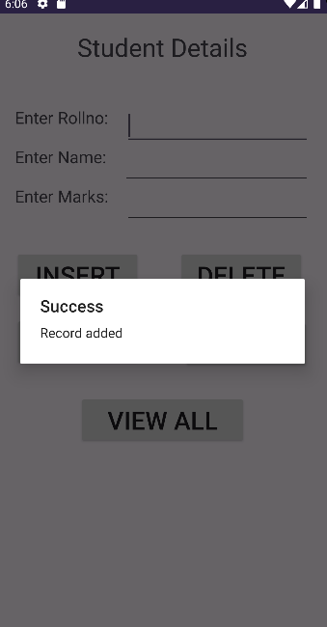

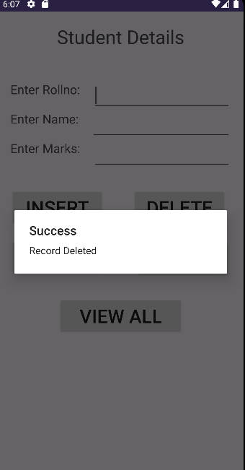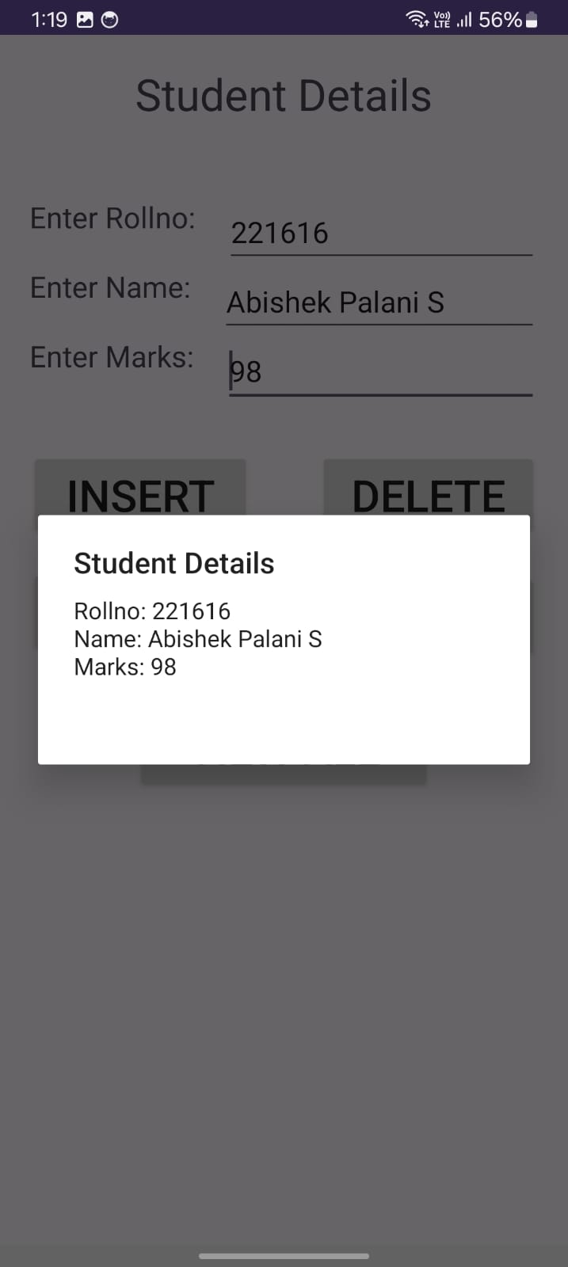

|  |  |  |
| --- | --- | --- |
| **Ex.No** |  | **Date** |
|  |  |

**SOURCE CODE:**

**XML CODE:**

<?xml version="1.0" encoding="utf-8"?>  
<LinearLayout xmlns:android="http://schemas.android.com/apk/res/android"  
 android:orientation="vertical"  
 android:layout_width="match_parent"  
 android:layout_height="match_parent">  
  
 <ListView  
 android:id="@+id/rssFeedListView"  
 android:layout_width="match_parent"  
 android:layout_height="wrap_content"  
 android:dividerHeight="1dp"/>  
</LinearLayout>

**MANIFEST CODE:**

<manifest xmlns:android="http://schemas.android.com/apk/res/android"  
 package="com.example.exno6">  
  
 <uses-permission android:name="android.permission.INTERNET"/>  
  
 <application  
 android:allowBackup="true"  
 android:icon="@mipmap/ic_launcher"  
 android:label="@string/app_name"  
 android:roundIcon="@mipmap/ic_launcher_round"  
 android:supportsRtl="true"  
 android:theme="@style/Theme.RSSFeedApp">  
 <activity android:name=".MainActivity"  
 android:exported="true">  
 <intent-filter>  
 <action android:name="android.intent.action.MAIN" />  
 <category android:name="android.intent.category.LAUNCHER" />  
 </intent-filter>  
 </activity>  
 </application>  
</manifest>

**JAVA CODE:**

package com.example.exno6;  
  
import androidx.appcompat.app.AppCompatActivity;  
import android.os.AsyncTask;  
import android.os.Bundle;  
import android.util.Xml;  
import android.widget.ArrayAdapter;  
import android.widget.ListView;  
import org.xmlpull.v1.XmlPullParser;  
import org.xmlpull.v1.XmlPullParserException;  
import java.io.IOException;  
import java.io.InputStream;  
import java.net.HttpURLConnection;  
import java.net.URL;  
import java.util.ArrayList;  
import java.util.List;  
  
public class MainActivity extends AppCompatActivity {  
  
 ListView rssFeedListView;  
 List<String> titles = new ArrayList<>();  
  
 @Override  
 protected void onCreate(Bundle savedInstanceState) {  
 super.onCreate(savedInstanceState);  
 setContentView(R.layout.*activity_main*);  
  
 rssFeedListView = findViewById(R.id.*rssFeedListView*);  
  
 new FetchFeedTask().execute("https://www.nasa.gov/rss/dyn/breaking_news.rss");  
  
 }  
  
 private class FetchFeedTask extends AsyncTask<String, Void, List<String>> {  
  
 @Override  
 protected List<String> doInBackground(String... urls) {  
 try {  
 return loadRssFeed(urls[0]);  
 } catch (IOException | XmlPullParserException e) {  
 e.printStackTrace();  
 return new ArrayList<>();  
 }  
 }  
  
 @Override  
 protected void onPostExecute(List<String> result) {  
 super.onPostExecute(result);  
 ArrayAdapter<String> adapter = new ArrayAdapter<>(MainActivity.this,  
 android.R.layout.*simple_list_item_1*, result);  
 rssFeedListView.setAdapter(adapter);  
 }  
  
 private List<String> loadRssFeed(String urlString) throws IOException, XmlPullParserException {  
 InputStream inputStream = null;  
 try {  
 URL url = new URL(urlString);  
 HttpURLConnection connection = (HttpURLConnection) url.openConnection();  
 connection.setRequestMethod("GET");  
 connection.connect();  
 inputStream = connection.getInputStream();  
 return parseXml(inputStream);  
 } finally {  
 if (inputStream != null) {  
 inputStream.close();  
 }  
 }  
 }  
  
 private List<String> parseXml(InputStream inputStream) throws XmlPullParserException, IOException {  
 List<String> titles = new ArrayList<>();  
 XmlPullParser parser = Xml.*newPullParser*();  
 parser.setFeature(XmlPullParser.*FEATURE_PROCESS_NAMESPACES*, false);  
 parser.setInput(inputStream, null);  
  
 String tagName;  
 boolean insideItem = false;  
  
 int eventType = parser.getEventType();  
 while (eventType != XmlPullParser.*END_DOCUMENT*) {  
 tagName = parser.getName();  
 switch (eventType) {  
 case XmlPullParser.*START_TAG*:  
 if (tagName.equalsIgnoreCase("item")) {  
 insideItem = true;  
 } else if (insideItem && tagName.equalsIgnoreCase("title")) {  
 titles.add(parser.nextText());  
 }  
 break;  
  
 case XmlPullParser.*END_TAG*:  
 if (tagName.equalsIgnoreCase("item")) {  
 insideItem = false;  
 }  
 break;  
 }  
 eventType = parser.next();  
 }  
 return titles;  
 }  
 }  
}

**OUTPUT:**

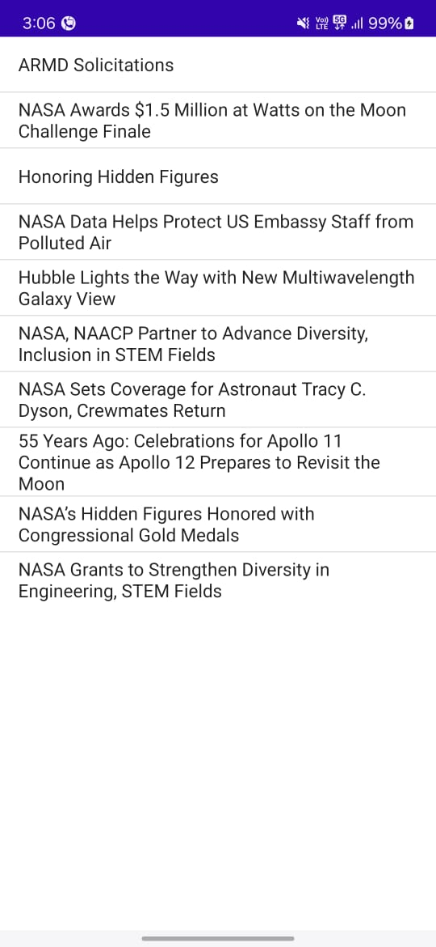

|  |  |  |
| --- | --- | --- |
| **Ex.No** |  | **Date** |
|  |  |

**SOURCE CODE:**

**XML CODE:**

<?xml version="1.0" encoding="utf-8"?>  
<LinearLayout xmlns:android="http://schemas.android.com/apk/res/android"  
 android:layout_width="match_parent"  
 android:layout_height="match_parent"  
 android:orientation="vertical">  
  
 <ImageView  
 android:id="@+id/imageView"  
 android:layout_width="250dp"  
 android:layout_height="250dp"  
 android:layout_margin="50dp"  
 android:layout_gravity="center" />  
  
 <Button  
 android:id="@+id/button"  
 android:layout_width="wrap_content"  
 android:layout_height="wrap_content"  
 android:layout_margin="10dp"  
 android:layout_gravity="center"  
 android:text="Load Image 1" />  
  
 <Button  
 android:id="@+id/button2"  
 android:layout_width="wrap_content"  
 android:layout_height="wrap_content"  
 android:layout_margin="10dp"  
 android:layout_gravity="center"  
 android:text="Load Image 2" />  
  
</LinearLayout>

**JAVA CODE:**

package com.example.exno7;  
  
import android.os.Bundle;  
import androidx.appcompat.app.AppCompatActivity;  
import android.view.View;  
import android.widget.Button;  
import android.widget.ImageView;  
public class MainActivity extends AppCompatActivity {  
 ImageView img;  
 Button bt1, bt2;  
  
 @Override  
 protected void onCreate(Bundle savedInstanceState) {  
 super.onCreate(savedInstanceState);  
 setContentView(R.layout.*activity_main*);  
 bt1 = findViewById(R.id.*button*);  
 bt2 = findViewById(R.id.*button2*);  
 img = findViewById(R.id.*imageView*);  
 bt1.setOnClickListener(new View.OnClickListener() {  
 @Override  
 public void onClick(View v) {  
 new Thread(new Runnable() {  
 @Override  
 public void run() {  
 img.post(new Runnable() {  
 @Override  
 public void run() {  
 img.setImageResource(R.drawable.*india1*);}  
 });  
 }  
 }).start();  
 }  
 });  
 bt2.setOnClickListener(new View.OnClickListener() {  
 @Override  
 public void onClick(View v) {  
 new Thread(new Runnable() {  
 @Override  
 public void run() {  
 img.post(new Runnable() {  
 @Override  
 public void run() {  
 img.setImageResource(R.drawable.*india2*);}  
 });  
 }  
 }).start();  
 }  
 });  
 }  
}

**OUTPUT:**

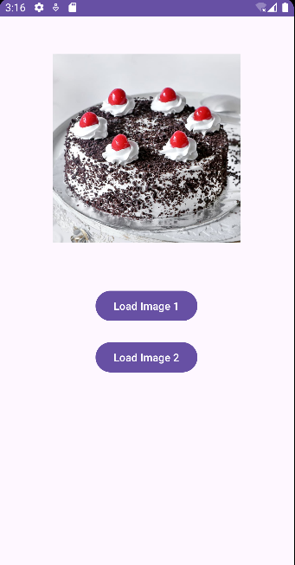 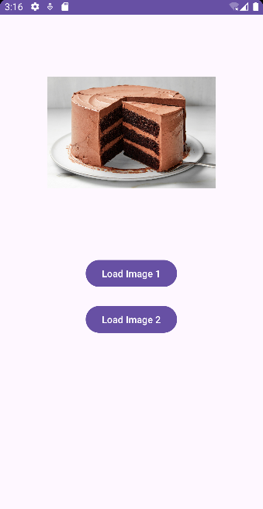

|  |  |  |
| --- | --- | --- |
| **Ex.No** |  | **Date** |
|  |  |

**SOURCE CODE:**

**XML CODE:**

<?xml version="1.0" encoding="utf-8"?>  
<RelativeLayout xmlns:android="http://schemas.android.com/apk/res/android"  
 android:layout_width="match_parent"  
 android:layout_height="match_parent"  
 android:padding="16dp"  
 android:background="#8A2BE2">  
  
 <TextView  
 android:id="@+id/titleText"  
 android:layout_width="wrap_content"  
 android:layout_height="wrap_content"  
 android:text="EXNO8"  
 android:textSize="24sp"  
 android:textColor="#FFFFFF"  
 android:layout_centerHorizontal="true"  
 android:layout_marginTop="50dp"/>  
  
 <Button  
 android:id="@+id/locationButton"  
 android:layout_width="wrap_content"  
 android:layout_height="wrap_content"  
 android:text="GET LOCATION"  
 android:layout_centerHorizontal="true"  
 android:layout_below="@id/titleText"  
 android:layout_marginTop="20dp"/>  
  
 <TextView  
 android:id="@+id/latitudeText"  
 android:layout_width="wrap_content"  
 android:layout_height="wrap_content"  
 android:text="Latitude: "  
 android:textColor="#FFFFFF"  
 android:layout_below="@id/locationButton"  
 android:layout_marginTop="20dp"  
 android:layout_centerHorizontal="true"/>  
  
 <TextView  
 android:id="@+id/longitudeText"  
 android:layout_width="wrap_content"  
 android:layout_height="wrap_content"  
 android:text="Longitude: "  
 android:textColor="#FFFFFF"  
 android:layout_below="@id/latitudeText"  
 android:layout_marginTop="10dp"  
 android:layout_centerHorizontal="true"/>  
</RelativeLayout>

**MANIFEST CODE:**

<manifest xmlns:android="http://schemas.android.com/apk/res/android"  
 package="com.example.exno8">  
  
 <uses-permission android:name="android.permission.ACCESS_FINE_LOCATION"/>  
 <uses-permission android:name="android.permission.ACCESS_COARSE_LOCATION"/>  
   
 <application  
 android:allowBackup="true"  
 android:icon="@mipmap/ic_launcher"  
 android:label="@string/app_name"  
 android:roundIcon="@mipmap/ic_launcher_round"  
 android:supportsRtl="true"  
 android:theme="@style/AppTheme">  
 <activity android:name=".MainActivity"  
 android:exported="true">  
 <intent-filter>  
 <action android:name="android.intent.action.MAIN"/>  
 <category android:name="android.intent.category.LAUNCHER"/>  
 </intent-filter>  
 </activity>  
 </application>  
</manifest>

**JAVA CODE:**

package com.example.exno8;

import android.Manifest;

import android.content.pm.PackageManager;

import android.location.Location;

import android.os.Bundle;

import android.widget.Button;

import android.widget.TextView;

import androidx.annotation.NonNull;

import androidx.appcompat.app.AppCompatActivity;

import androidx.core.app.ActivityCompat;

import androidx.core.content.ContextCompat;

import com.google.android.gms.location.FusedLocationProviderClient;

import com.google.android.gms.location.LocationServices;

import com.google.android.gms.tasks.OnSuccessListener;

public class MainActivity extends AppCompatActivity {

private static final int LOCATION_PERMISSION_REQUEST_CODE = 1;

private FusedLocationProviderClient fusedLocationClient;

private TextView latitudeText;

private TextView longitudeText;

@Override

protected void onCreate(Bundle savedInstanceState) {

super.onCreate(savedInstanceState);

setContentView(R.layout.activity_main);

latitudeText = findViewById(R.id.latitudeText);

longitudeText = findViewById(R.id.longitudeText);

Button locationButton = findViewById(R.id.locationButton);

fusedLocationClient = LocationServices.getFusedLocationProviderClient(this);

locationButton.setOnClickListener(v -> getLocation());

}

private void getLocation() {

if (ContextCompat.checkSelfPermission(this, Manifest.permission.ACCESS_FINE_LOCATION) != PackageManager.PERMISSION_GRANTED) {

ActivityCompat.requestPermissions(this, new String[]{Manifest.permission.ACCESS_FINE_LOCATION}, LOCATION_PERMISSION_REQUEST_CODE);

} else {

fusedLocationClient.getLastLocation().addOnSuccessListener(this, new OnSuccessListener<Location>() {

@Override

public void onSuccess(Location location) {

if (location != null) {

latitudeText.setText("Latitude: " + location.getLatitude());

longitudeText.setText("Longitude: " + location.getLongitude());

}

}

});

}

}

@Override

public void onRequestPermissionsResult(int requestCode, @NonNull String[] permissions, @NonNull int[] grantResults) {

super.onRequestPermissionsResult(requestCode, permissions, grantResults);

if (requestCode == LOCATION_PERMISSION_REQUEST_CODE) {

if (grantResults.length > 0 && grantResults[0] == PackageManager.PERMISSION_GRANTED) {

getLocation();

}

}

}

}

**OUTPUT:**

